The case of the
Human Remains

Using measurements of the skeleton

Paul Redmond
The case of the Human Remains
Curriculum: The Skeleton

Teachers (what you need):
1 tibia Bone
1 humerus bone (different size to tibia)
metre Sticks
(Bones can be drawn and cut out from cardboard)

Bones should be different in proportion to each other so that students can discover that they are from two different bodies. This will lead to them advising police to look for two bodies instead of one in the plane wreckage.
(Forensic Science for High School/ Barbara Deslich & John Funkhouser)
The case of the Human Remains
The Case:
A large charred torso was recovered from the Cerritos air crash disaster in Los Angeles County in Sept 1986. The remains consisted of portions of a head, trunk, left leg (Tibia) and right arm (humerus) the nose and facial features were gone, although some of the teeth were still there. Neither age nor gender was obvious.
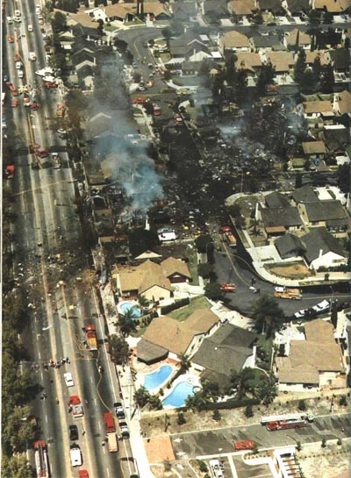
The Science:
A person’s height can be determined by examining a person’s long bones (e.g. Femur, Tibia, Humerus, and radius). Men and women have different proportions of long bones to total height so different formulas are used. These formulas can be used to calculate the person’s height within 7.5 cm's.
Male: (Centimetre)
H = Femur length x 2.23 + 69.08
H = Tibia length x 2.39 + 81.68
H= Humerus Length x 2.97 + 73.57
H= Radius length x 3.65 + 80.40
Female: (Centimetre)
H= Femur Length x 2.23 + 69.08
H= Tibia length x 2.39 + 81.68
H= Humerus length x 2.97 + 73.57
H= Radius length ` x 3.65 + 80.40

Task 1:
Measure the length of each of the bones recovered from the plane crash.
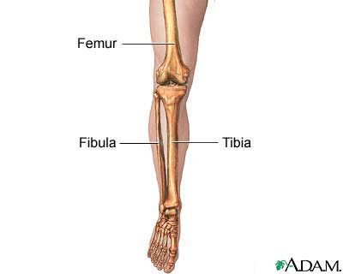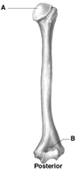

Tibia _____________cm Humerus_______________cm
http://www.quincymedgroup.com
http://science.uniserve.edu.au

Task 2:
Calculate the height of the person recovered from the crash if male or female using the measurements from both bones
 | Male | Female
Tibia
Humerus
.

What advice if any would you give to the Police after these initial two tasks?

Task 3:
Workings in pairs measure your own height (cm) and from this what would you expect to be the length of your own Femur Bone?

Task 4
Use the class skeleton as your specimen.
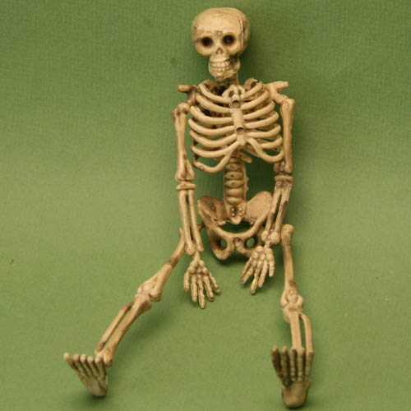 (http://z.about.com)

Measure the height of the skeleton. Now using the formulae you have learned to carry out some calculations to find out whether the skeleton is male or female.

Summary Questions:
- What is the function of the skeleton?

- How many bones in the human body?

- Name two long bones

- Name the two bones in the lower leg

- Name two bones involved in protection

